Week 3 Readings
Complete the following readings early in the week:
- Read the Week 3 Online Lectures.
- Read pages 98-121 from Albert's Basic Figure Drawing Techniques.
- Read pages 48-55, 78-85 and 10-21, from Peck's Atlas of Human Anatomy for the Artist.
- Read pages 122-127, 138-143 and 94-101, from Peck's Atlas of Human Anatomy for the Artist.
Week 3 Assignments Overview
Assignment Summary: Week 3 | Due Date
Assignment 1: Hands and Feet Anatomy Drawing | Wednesday, July 30, 2008
Assignment 2: The Skull/Head/Neck Anatomy Drawing | Friday, August 1, 2008
Assignment 3: Midterm Review and Critique | Saturday, August 2, 2008
Remember that all Assignment details can be found on the assignment pages located throughout the week. Go to those specific pages for direction on how to complete each individual assignment.

Assignment 1: Hands and Feet Anatomy Drawing
Anatomy Study:
By Wednesday, July 30, 2008, sketch the skeletal system and muscular system of the hands. Please reference Peck's Atlas of Human Anatomy for the Artist, pages 122 and 50 to study these bones. Submit your responses to the appropriate Discussion Area.
Example:
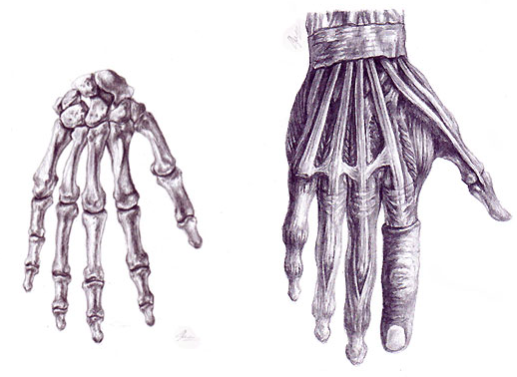

Anatomy Study:

By Wednesday, July 30, 2008, sketch the skeletal system and muscular system of the Feet.Please reference Peck's Atlas of Human Anatomy for the Artist, pages 138 and 80 to study these bones. Submit your responses to the appropriate Discussion Area.
Example:
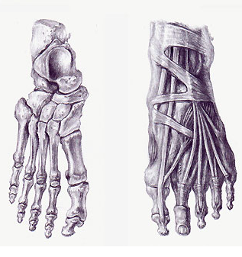
Assignment 1 Grading Criteria: | Maximum Points
Balance, scale and proportion, sketch and value, and overall unity of elements. | 8
Completeness of assignment. | 8
Clean, well crafted, and technically sound work. | 8
Participated in discussion with class, feedback and comments. | 4
Total: | 28
For assistance with any problems you may have when completing this assignment—OR—to offer your assistance to classmates, please use the Problems and Solutions Discussion area located through the left side navigation link.

Assignment 2: The Skull/Head Anatomy Drawing
Complete this assignment by Friday, August 1, 2008 and post it to the appropriate thread in the Discussion Area. Review and critique the work of at least two other students early in the week.
Anatomy Drawing
Draw the skeletal system of the skull doing a front and a side view. Please refer to pages 14 and 16 in Atlas of Human Anatomy for the Artist. These should be fully rendered drawings and require 1-2 hours to complete.
Example:
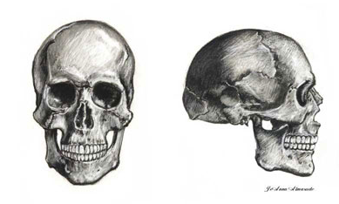
Assignment 2 Grading Criteria | Maximum Points
Balance, scale and proportion, sketch and value, and overall unity of elements. | 4
Clean, well crafted, and technically sound work. | 4
Correctly labeled bones. | 4
Participated in discussion with class, feedback and comments. | 4
Total: | 16
For assistance with any problems you may have when completing this assignment—OR—to offer your assistance to classmates, please use the Problems and Solutions Discussion area located through the left side navigation link.

Assignment 3: Midterm Review and Critique
By Saturday, August 2, 2008, write a two-paragraph summary about what you have learned up to the midterm on proportion and anatomy studies, and post it to the Discussion Area.
Questions to consider:
Do you feel like you have improved your skills?
What are areas that you feel you need to work on?
How might the anatomy studies help to inform your knowledge and assessment of body proportions?
Feel free to discuss the assignments and your impressions of the experience.
Next, offer a two paragraph summary critique on the work completed up to the midterm of the peer immediately following your name in the roster. If this person is no longer listed in the roster, move on to the next person. Consider strengths and areas for improvement with respect to the proportion and anatomy exercises
Assignment 3 Grading Criteria | Maximum Points
Student uses terminology and relates concepts introduced in course studies throughout discussion contributions. Student brings additional questions and observations into the discussion. | 4
Student communicates ideas in a manner that is clear and complete, leaving no information implied. | 4
Summary contributions adhere to project specifications regarding format, focus, and deadline. | 4
Timely response to comments of classmates' discussions. | 4
Reflects the efforts of the student to produce clean, well-crafted, and technically sound worksheet at this stage of the project. | 4
Participation in discussion with class, feedback and comments. | 4
Total: | 24
For assistance with any problems you may have when completing this assignment—OR—to offer your assistance to classmates, please use the Problems and Solutions Discussion area located through the left side navigation link.

Do you feel like you have improved your skills?
What are areas that you feel you need to work on?
How might the anatomy studies help to inform your knowledge and assessment of body proportions?
Feel free to discuss the assignments and your impressions of the experience.
Next, offer a two paragraph summary critique on the work completed up to the midterm of the peer immediately following your name in the roster. If this person is no longer listed in the roster, move on to the next person. Consider strengths and areas for improvement with respect to the proportion and anatomy exercises

